**Box Model**

**Introduction:**

The box model in CSS describes how elements are rendered on a web page. It consists of four components: content, padding, border, and margin. Understanding the box model is crucial for precise control over element sizing and positioning.

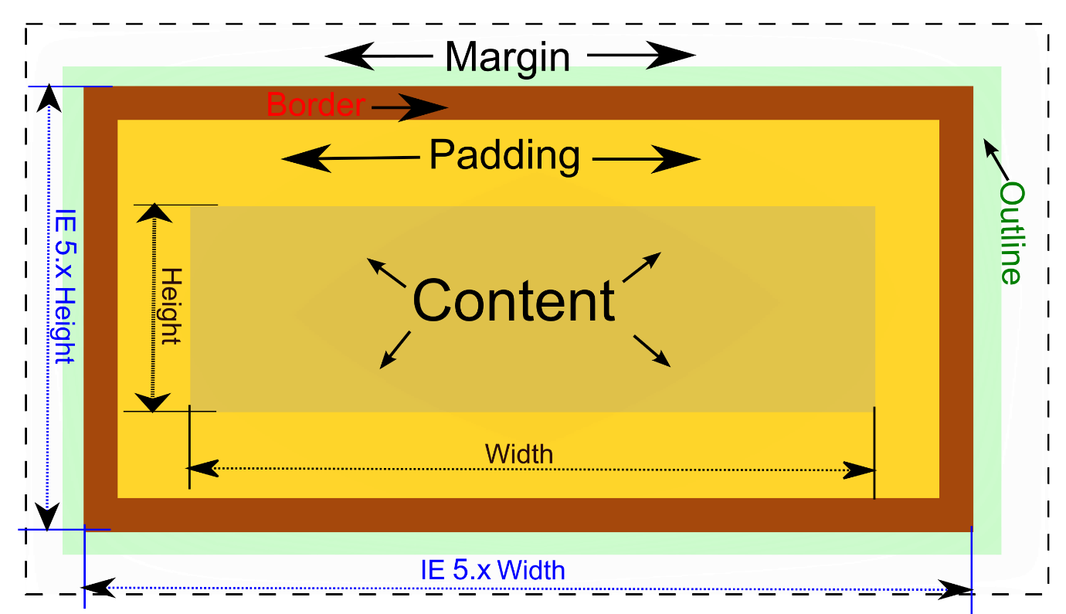

**Real-life example:**

Let's imagine you are building a recipe website. Each recipe card on the website needs to have a consistent layout with appropriate spacing and borders. By applying the principles of the box model, you can ensure that the recipe cards have proper padding to separate the content from the borders and sufficient margins to create space between each card. This helps in creating an organized and visually appealing recipe gallery.

Difference from general:

The box model allows us to visualize and manipulate the space occupied by an element on a web page. It includes not only the content of the element but also its padding, border, and margin. The box model helps in accurately determining the overall size and positioning of an element.

**Code-based example:**

**Here's an example of how to apply the box model in CSS:**

**html**:-

<div class="recipe-card">

<h2>Delicious Chocolate Chip Cookies</h2>

<p>Ingredients: ...</p>

</div>

**css**:-

.recipe-card {

width: 300px;

padding: 20px;

border: 1px solid #ccc;

margin-bottom: 20px;

}

In this example, we have a recipe card represented by a <div> element with the class "recipe-card." We set the width of the card to 300 pixels using the width property. Then, we apply padding of 20 pixels to create space between the content and the border. A border of 1 pixel solid #ccc is added to define the visual boundary of the card. Finally, we set a bottom margin of 20 pixels to create space between the recipe cards.

**CSS Margin and Padding**

we'll be delving into the topic of CSS margin and padding. They are essential properties for controlling spacing and layout in CSS.

**Introduction**:

Margin and padding are CSS properties that allow us to control the spacing around elements. They provide flexibility in adjusting the layout and creating visual separation between elements.

**Margin** :-

* Margin is the space outside an element. It controls the space between an element and its neighboring elements.
* It affects the overall layout and spacing of elements on the page.

**Padding**:-

* Padding is the space within an element. It controls the space between the content of an element and its border.
* It affects the internal spacing and alignment of the content within an element.

**Real-life example:**

Imagine you are designing a personal portfolio website. You want to create sections with clear separation and spacing between them. Margin and padding come in handy to achieve this. By applying appropriate margins, you can control the space between different sections, while padding helps in maintaining a consistent internal spacing for content within each section. This creates a visually appealing and organized layout for your portfolio.

Code-based example:

**HTML**:-

<div class="section">

<h2>About Me</h2>

<p>Lorem ipsum dolor sit amet, consectetur adipiscing elit.</p>

</div>

**CSS**:-

.section{

background-color: #f2f2f2;

margin-bottom: 20px;

padding: 20px;

}

h2 {

margin-bottom: 10px;

}

p {

margin-bottom: 0;

}

In this example, we have a section element with a background color, margin, and padding. The margin-bottom property creates spacing between sections, while the padding property adds internal spacing within the section. Additionally, we have adjusted the margin of the h2 and p elements to fine-tune the spacing.

**CSS** **Shadows**

we'll be exploring the topic of CSS shadows. It's an interesting feature that allows you to add depth and dimension to your elements.

**Introduction**:

CSS shadows provide a way to add shadows to elements, making them visually stand out and appear more realistic. Shadows can be applied to text, boxes, and other elements to create various effects and enhance the overall design.

While other CSS properties focus on the visual appearance of the element itself, shadows specifically enhance the surrounding area. They create an illusion of depth and can be used to simulate lighting effects, giving elements a more three-dimensional feel.

**Real-life example:**

Let's imagine you are designing a website for a photography portfolio. You want to make the images pop and create a sense of depth. By applying subtle box shadows to the image containers, you can give the impression that the images are slightly floating above the page, adding a professional touch to the portfolio.

**Code-based example:**

Here's an example of how to use box shadow in CSS:

**Html**:-

<div class="image-container">

<img src="" alt="">

</div>

**css**:-

.image-container {

300px;

height: 200px;

box-shadow: 2px 2px 4px rgba(0, 0, 0, 0.4);

}

img{

height:50px;

width: 50px;

}

In this example, we have an image container with a width of 300 pixels and a height of 200 pixels. By applying the box-shadow property, we add a subtle shadow effect to the container. The values 2px 2px 4px rgba(0, 0, 0, 0.4) represent the horizontal offset, vertical offset, blur radius, and color of the shadow, respectively.

**CSS text-effects**

we'll be exploring CSS text-effects. It's an interesting topic that allows us to add creative and eye-catching effects to our text.

**Introduction**:

CSS text-effects provide a range of styling options to enhance the appearance of text. With these effects, you can make your text stand out, add emphasis, or create unique visual effects.

**Real-life example:**

Let's say you're working on a website for a music festival. You want to create a dynamic and energetic atmosphere for the festival's title on the homepage. By using CSS text-effects, you can apply animations, gradients, or transformations to the text, making it visually appealing and capturing the essence of the event.

**Difference from general:**

While general CSS properties focus on styling the layout and appearance of elements as a whole, CSS text-effects specifically target the text content. They allow you to apply special styles and transformations to the text, giving it a unique and engaging visual presentation.

**Code-based example:**

**html:-**

<h1 class="glowing-text">Welcome to music festival</h1>

**css**:-

.glowing-text{

font-size: 48px;

color: #ffcc00;

text-shadow: 0 0 10px #ffcc00;

}

In this example, we have a heading element with the class "glowing-text." We set the font size and color, and then use the text-shadow property to add a glowing effect around the text.